FY Measurements

1. The measurements are inaccurate but precise
2. 0.4 ± 0.1
3. Method A: One measurement per hour = 8x103Ω  
   Method B: Eight hour setup, one measurement every fifteen minutes, error is half of the present one (4x103Ω)  
   During a 24 hour interval, Method A will produce 24 measurements and Method B will produce 64 measurements with half the random error therefore they should use Method B to reduce their standard error
4. 27,380,742 = 2.7380742 ± 0.0000007 x 107

63,000 = 6.3 ± 0.4 x104  
470,200 = 4.70200 ± 0.00009 x 109  
43x10-14 = 4.3 ± 0.002 x 10-13

1. Mean =

SD = $\sqrt{\frac{{Sum\left(x-µ\right)}^{2}}{n}}=2$

1. z = xn  
   Δz = nxn-1  
   Δz/z = nxn-1/xn

Δx = z(1/n)-1/n

Δx/x = z(1/n)-1/nz1/n

1. The hypothesis that the extension is proportional to the mass loading is valid.
2. The elastic limit appears just after the 40 kg mass is applied
3. The extension caused by the 22.5kg mass looks like it may be a mistake as it does not fit the trend of results.
4. For a 17.5kg mass the extension would be 0.85mm
5. For a 52kg mass, the extension would be approximate to 3.6mm
6. There is no title, no y-axis label, no units, no key for the graph trend
7. 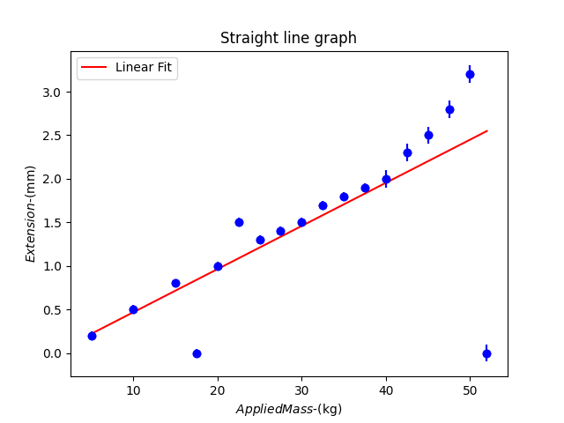
8. Had the values past 37.5kg not been given, I would assume the extension for the 52kg mass to be 2.6mm.
9. The period does not depend on the mass of the bob, only the length of the suspension as given by the formula:
$$T=2π\sqrt{\frac{L}{g}}$$

10. The pendulum will not be attached to a light string, will not be of uniform density and may not be properly attached to a chosen surface
11. Tn = CL which is equivalent to T2 = (4π2/g) x L  
    n=2, C=4π2/g (where g is acceleration due to gravity)
12. My length uncertainty is ± 0.05cm (as I have a cm rule with divisions of 0.1cm)  
    Time taken for 10 periods = 13.5 seconds
13. The error in this measurement is the human reaction time between observing the movement of the pendulum and pressing the lap button on the stopwatch which was 0.15 seconds on average. This value became more accurate as the human became more familiar with the process. Another possible method is to use a laser detector attached to a computer designed to count the passage in time between each period of the pendulum, lapping the time when the string crosses the beam. This increases the precision of the measurements significantly leaving a systemic error as a result of the instrument calibration instead of other factors.
14. Measuring 10 periods instead of once increases the accuracy of the average measurement.
15. Bob is of mass 500g

|  |  |
| --- | --- |
| Length (cm) | Period (s) |
| 20 | 10 |
| 25 | 10.5 |
| 30 | 11 |
| 35 | 12 |
| 40 | 13 |

1. For a Lighter bob of mass 300g

|  |  |
| --- | --- |
| Length (cm) | Period (s) |
| 20 | 10.2 |
| 25 | 10.7 |
| 30 | 11.3 |
| 35 | 12.1 |
| 40 | 13 |

23 – 27 can be found on the Measurements.xslx file

26.